|  |  |
| --- | --- |
| **Name:** Buo, Mark Jomar B. | **Date:** 08-12-2016 |
| **Course/Section:** CPE232/CPE42FC1 | **Instructor:** Engr. Clifford Arambala |
| **Activity 2 – Install and Configure Windows Server 2008 DNS Server** | |

* Intended Learning Outcomes

The student shall learn to install and configure in Windows Server 2008 the DNS Server and test it using client PC.

* Materials

1. Personal computer
2. Windows Server 2008 Standard and Windows 7 installed in VirtualBox.

* Procedure

Installing DNS Server

1. To install DNS server, go to Server Manager -> Add Roles.

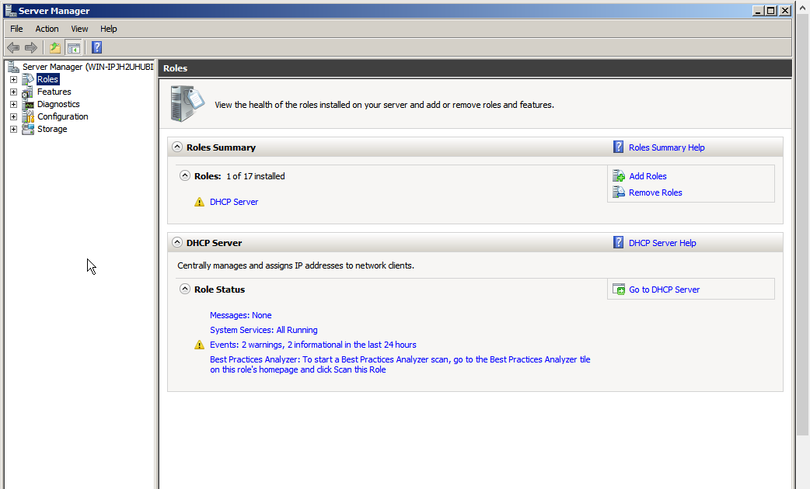

1. From Server Roles tab, check the DNS Server checkbox.

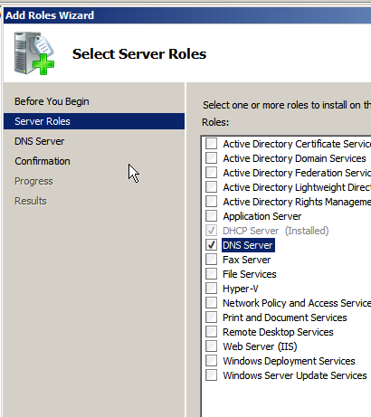

1. After clicking on next, an introduction to DNS server will pop out. Read carefully and click on next.

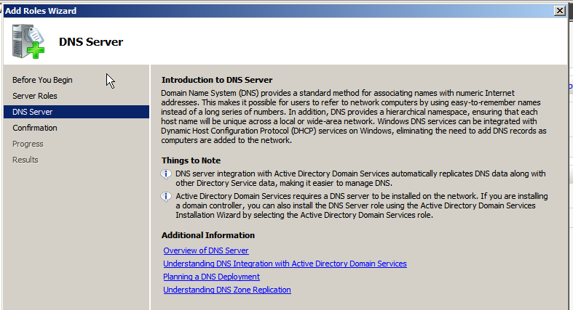

1. Confirm if DNS server is the pending role to install.

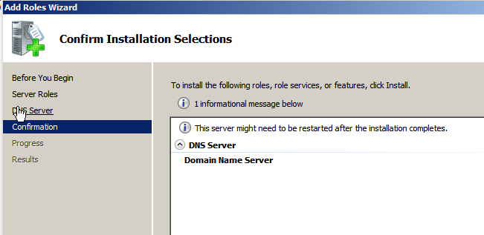

1. Click on next and wait to install.

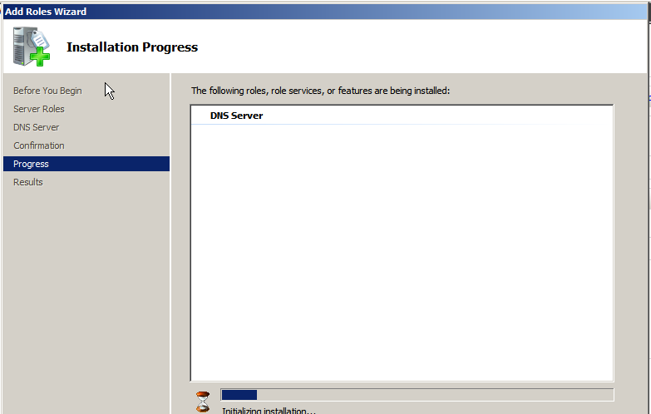

1. DNS server is now installed.

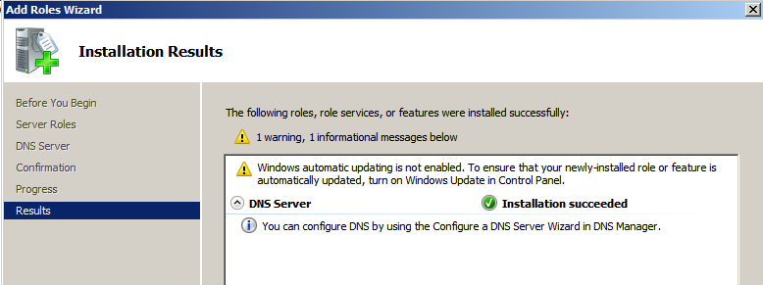

Configuring DNS Server

1. To configure DNS Server, go to Server Manager -> Roles -> DNS -> (name of server). Right Click the name of server name and click on Configure a DNS server.

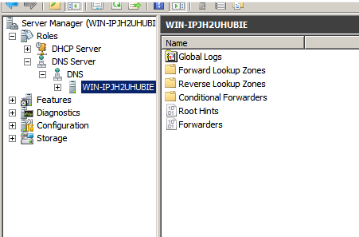

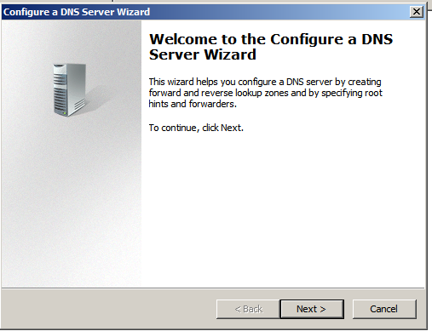

1. Choose the Create forward and reverse lookup zones and click on next.

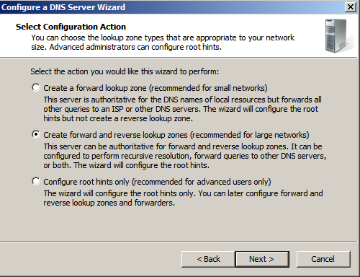

1. The first to configure is the forward zone. Choose yes to create a forward lookup zone.

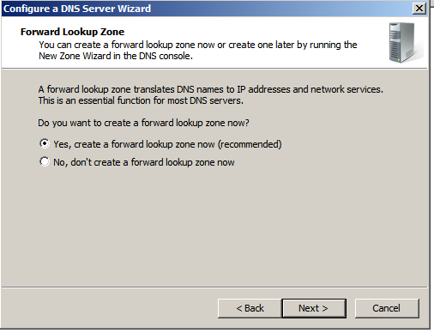

1. Choose Primary zone and click on next.

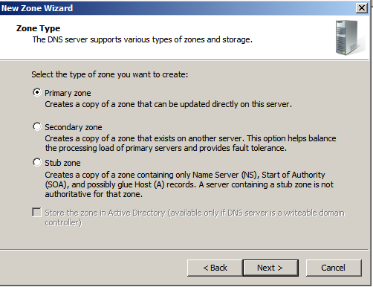

1. Fill up the zone name you want to have.

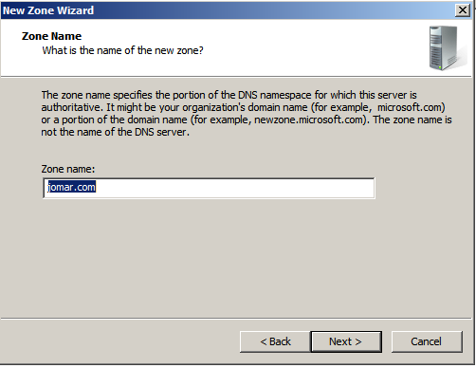

1. Choose to create a new file for new zone. Click on next.

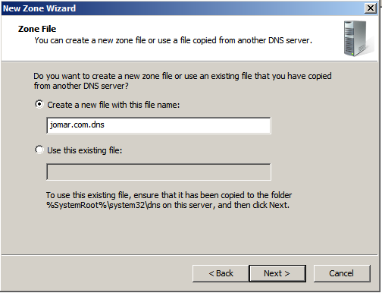

1. Choose not to allow dynamic updates and click on next.

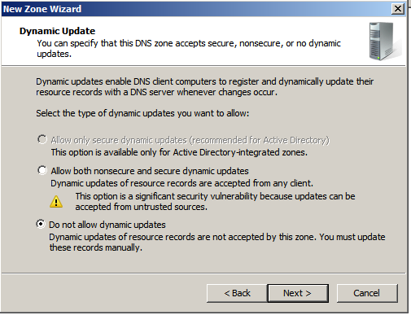

1. Second to configure is the Reverse zone. Choose yes to create a reverse lookup zone.

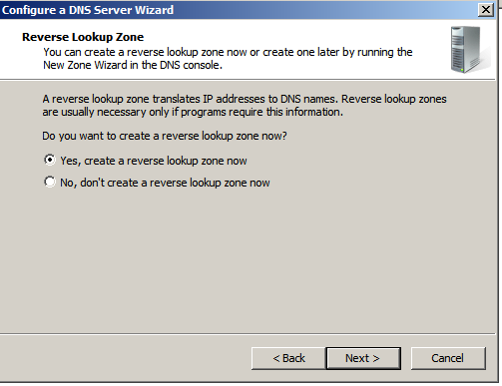

1. Choose primary zone and click on next.

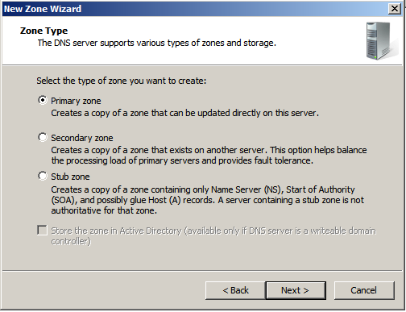

1. Choose the IPv4 Reverse Lookup Zone then click on next.

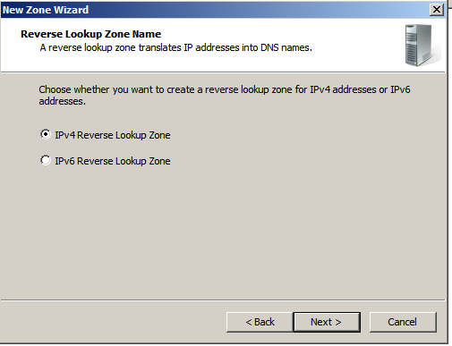

1. Fill up the Network ID. Type the 3 first octets of the IP address and click on next.

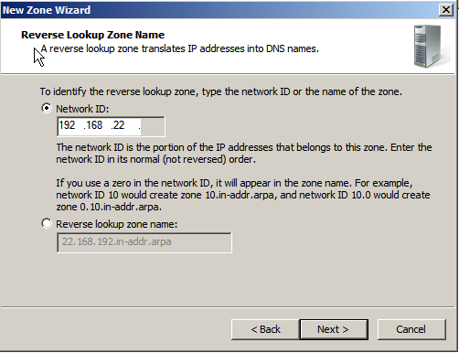

1. Choose create a new file for the new zone and click on next.

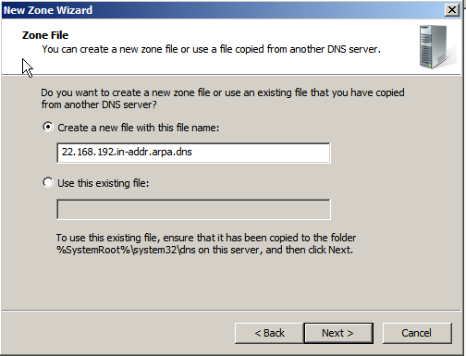

1. Choose not to allow dynamically updates.

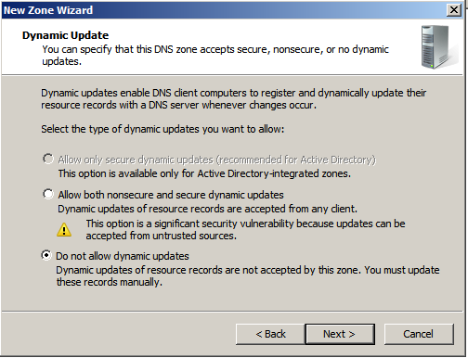

1. Choose not to send the queries if it fails to send queries to server.

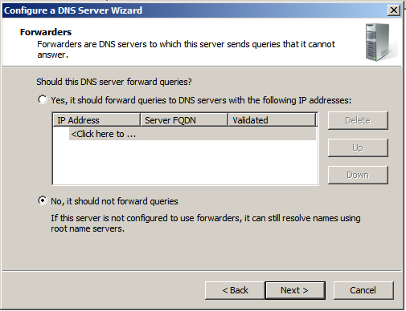

1. Click finish.

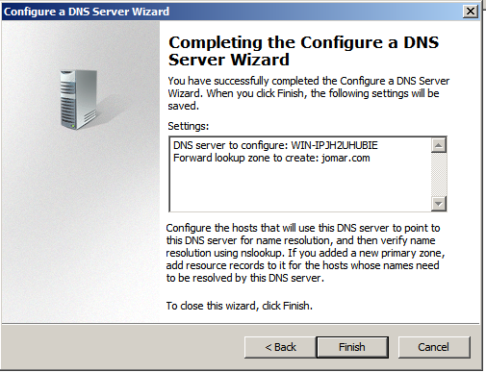

1. To have a Start of Authority (SOA), go to Server Manager -> Roles -> DNS -> (name of server computer) -> Forward Lookup Zones -> (zone name). Expand and double click the file which has the type of Start of Authority and fill up the necessary information.

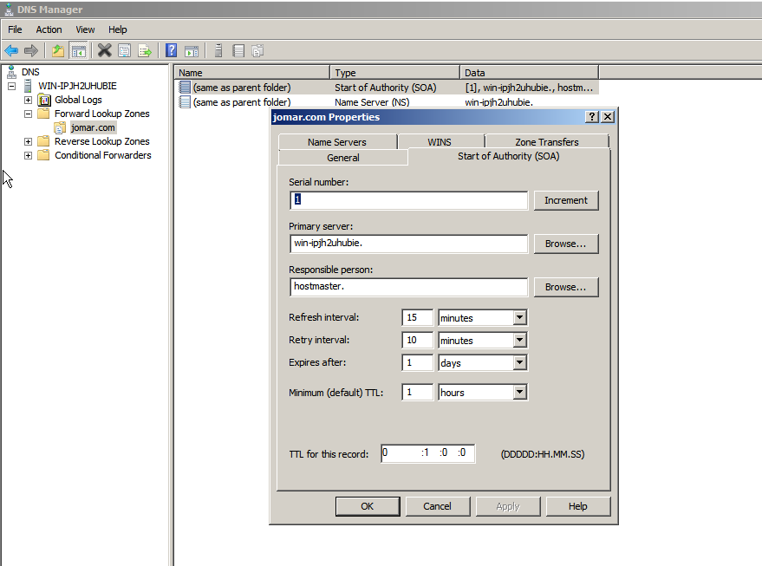

1. To create new name server, click on Name Servers tab and click on add.

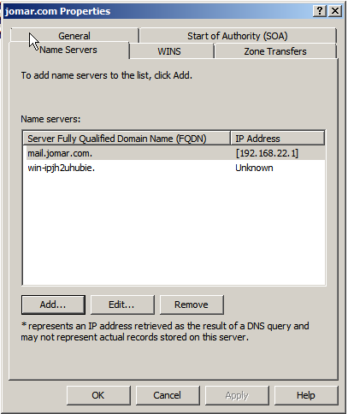

1. A New Name Server Record dialogue box will appear. Fill up the necessary information and click Ok.

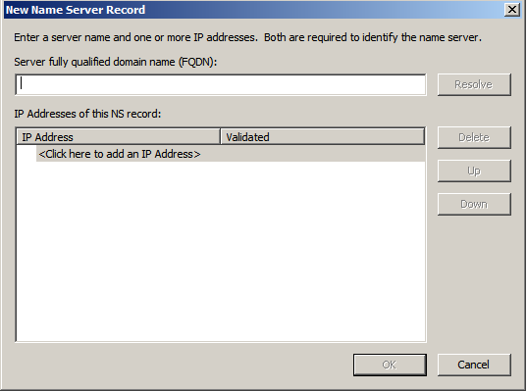

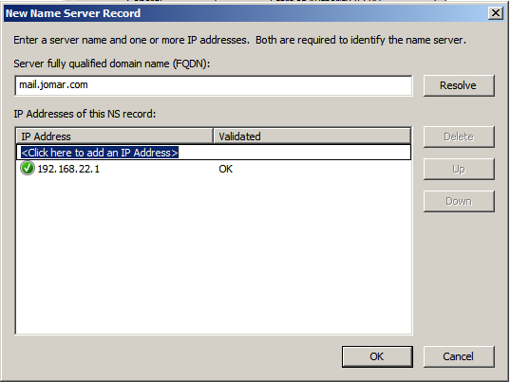

1. To create a new host, right click the zone folder and choose New Host. This will map a host name to an IP address.

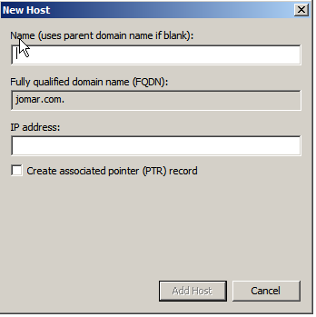

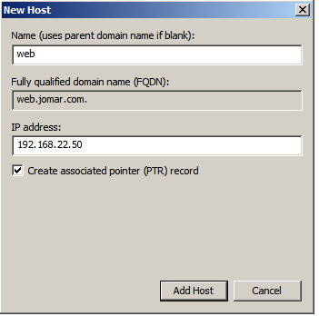

1. Forward Lookup Zones files will add file if you have configure the SOA, Name Servers and Hosts.

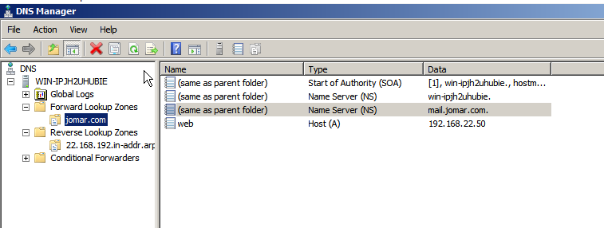

1. To configure PTR, click on Reverse Lookup zones -> reverse zone folder. Right Click the folder and click New Pointer. This will create appropriate entry in the reverse lookup zone for reverse queries. Fill up the necessary info and click ok.

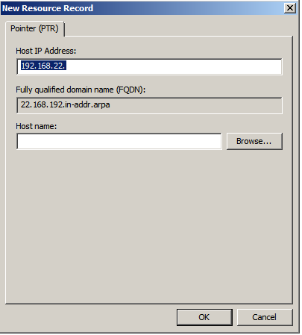

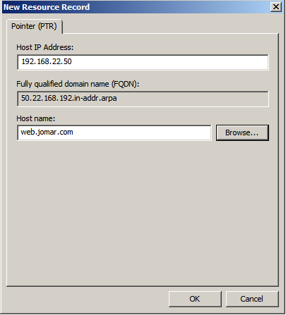

1. To create alias, click on Reverse Lookup zones -> reverse zone folder. Right Click the folder and click New Alias. This will create multiple names of your single host. Fill up the necessary information and click OK.

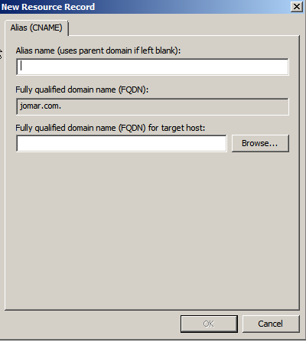

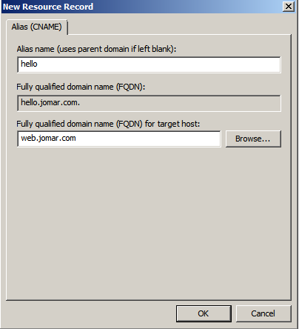

Testing the DNS Server

1. To test the created DNS server, the firewalls of both server and client must be off.

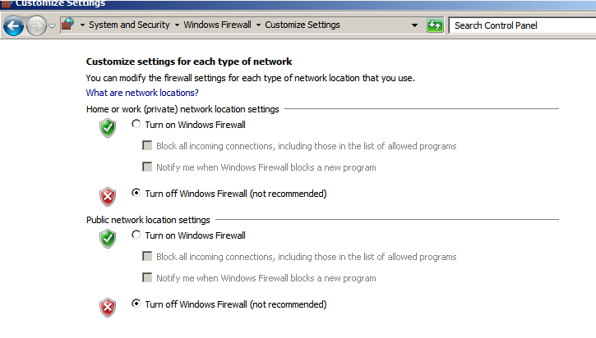

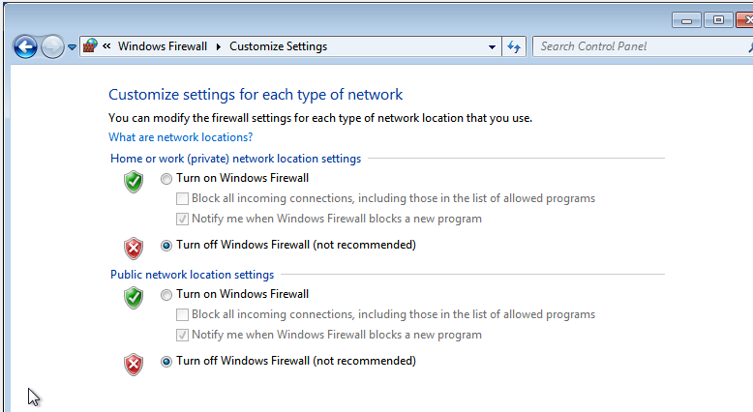

1. Go to cmd and try to ping the created DNS.

Using mail.jomar.com

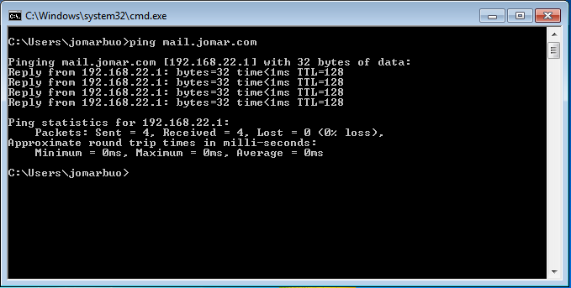

Using web.jomar.com

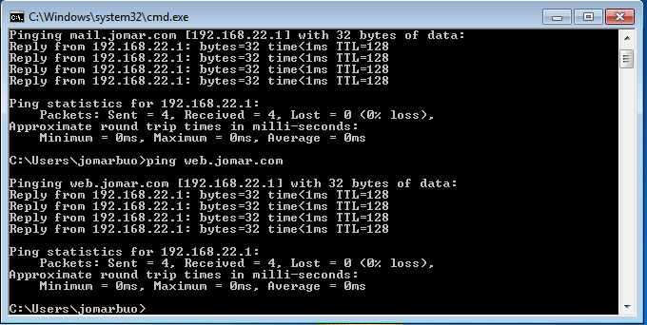

Using hello.jomar.com

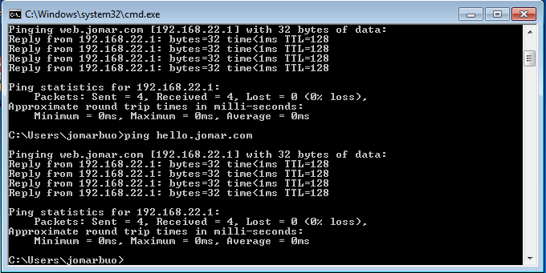

* Reflection

Unlike in the Ubuntu server, installing and configuring DNS server in Windows 2008 is in graphical user interface. But it is easier to configure in Ubuntu server because all the necessary information to configure DNS server is in one file unlike Windows Server, there are one file for every important information in DNS.